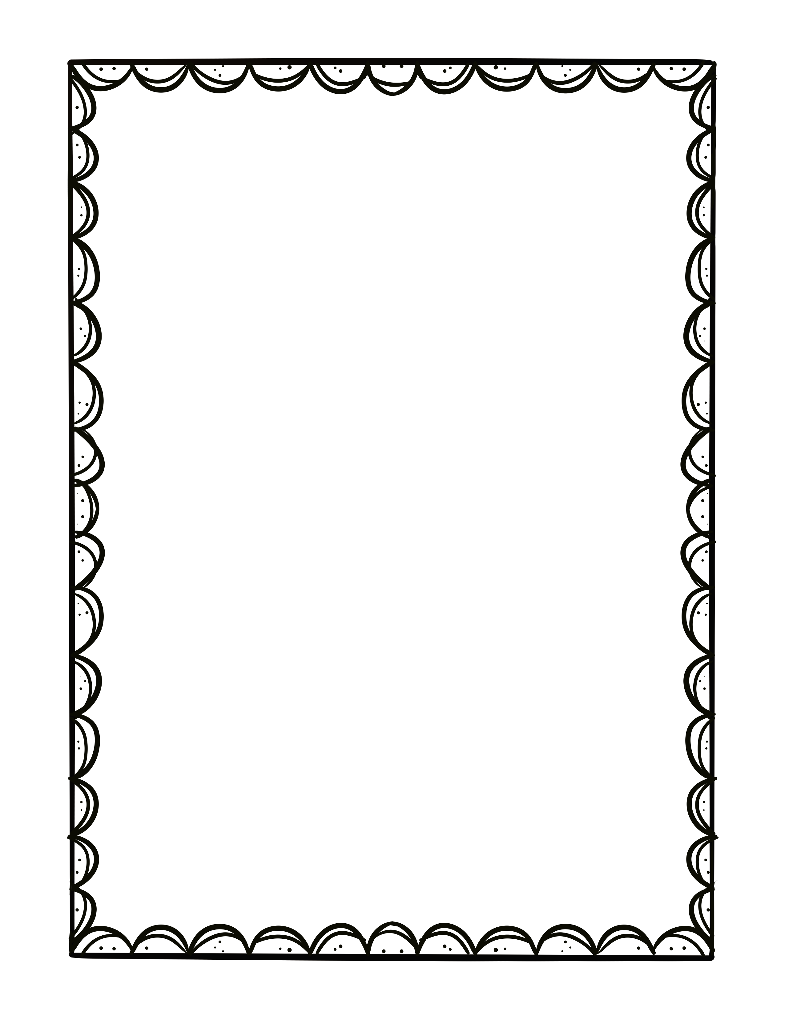幼儿园 Sight words

|  |  |  |  |
| --- | --- | --- | --- |
| List 1 | List 2 | List 3 | List 4 |
| I | is | are | look |
| can | get | he | good |
| the | little | so | when |
| we | she | with | come |
| see | was | here | does |
| a/an | for | me | bad |
| like | have | this | *that* |
| to | of | what | *am* |
| big | they | help | *it* |
| and | my | too | *if* |
| go | by | has | *in* |
| you | said | play | *not* |
| do | want | where | yes |

COLOR WORDS:

red orange yellow green blue purple white black brown

Number words:

1 one 2 two 3 three 4 four 5 five 6 six 7 seven 8 eight

9 nine 10 ten

**由**[**https://watermelonwater.tech**](https://watermelonwater.tech)**整理**